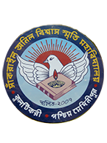
SANKRAIL ANIL BISWAS SMRITI MAHAVIDYALAYA
Affiliated to Vidyasagar University
Accredited by NAAC
AT & P.O- KULTIKRI, DIST- JHARGRAM, PIN-721135 (W.B.)

Memo No....................................... Date: 21/11/2020

NOTICE
It is herby informed to all 3rd and 5th semester General Course students that follow the instructions carefully regarding their online classes-

For 3rd Sem. Gen. Course

1. Selected DSC 1 subject (as mentioned in the admission slip/ registration copy) will be their SEC1 subject.

For 5th Sem. Gen. Course

1. Selected DSC 1 subject (as mentioned in the admission slip/ registration copy) will be their SEC 3 Subject.

2. The GE subject will be as per they have already selected during the 1st sem. admission.

Students are hereby also informed to collect the contact no. of the respective subject teachers from our college website and contact them as early as possible.

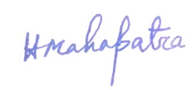
Teacher-in-Charge
